Reservation for Accommodation

Name | Room Type | Check in | Check out

Information of Accommodation for C-K-J Joint Seminar

Hotel : Koreana Hotel, 135 Sejong-daero, Jung-gu, Seoul, 04519, Korea
Room Type & Price
• Deluxe Type
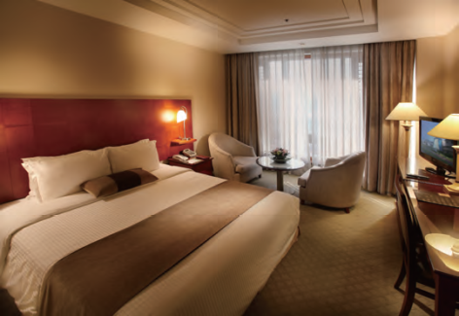 | 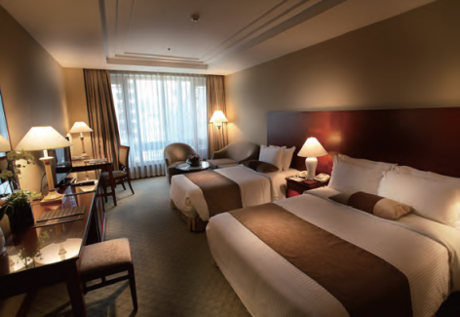
Deluxe Queen  Price : 139,000 KRW | Deluxe Twin  Price : 139,000 KRW
• Club Type
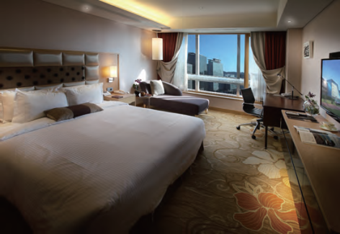 | 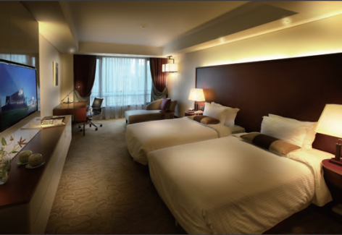
Club Queen  Price : 159,000 KRW | Club Twin  Price : 169,000 KRW
* Room rates include the buffet breakfast for a person, Internet service, a bottle of mineral
water, and 10% tax
* Additional breakfast : Deluxe type (16,500 KRW), Club type (16,500 KRW)

